Beverley St. Nicholas Primary School

Handwriting Policy


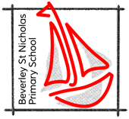

- Reviewed February 2026

Definition
- Handwriting is complex perceptual-motor skill that is dependent upon the maturation and integration of a number of cognitive, perceptual, and motor skills, which is developed through instruction (Hamstra-Bletz and Blote, 1993; Maeland, 1992). It is a complex process of handling language by pencil grip, letter formation, and body posture. Handwriting efficiency requires mastery of multiple skills, including vision, coordinating the eyes, arms, hands, memory, posture, and body control, as well as the task of holding a pencil and forming letters.

- Rationale
The skill of handwriting is a complex one to learn i.e., it is so much more than holding a pencil and forming letters. This policy seeks to ensure that all adults understand this and take this into account when teaching handwriting.

- The importance of handwriting in the curriculum
- Handwriting is concerned with individual expression and the conveying of meaning through fluent composition. Handwriting should become an automatic process, which frees pupils to focus on the content of their writing. In order for this to occur, handwriting is taught in ways that enhance fluency, legibility, purposefulness and the opportunity for creative expression. It is important that all adults model the correct formation at all times, when marking, teaching and for display.

National Curriculum 2014 states: ‘Writing…depends on fluent, legible and, eventually, speedy handwriting.’

Aims
We believe that effective handwriting is:
- Legible
- Presentable
- Comfortable
- Fluent
- Flexible
- Fast
- Automatic
- Sustainable

And that our children should progress through this list such that when they leave us at the end of Key Stage 2 their writing is flexible and fast.

Curriculum content (what we teach)

Year 2+ will use the Martin Harvey scheme.
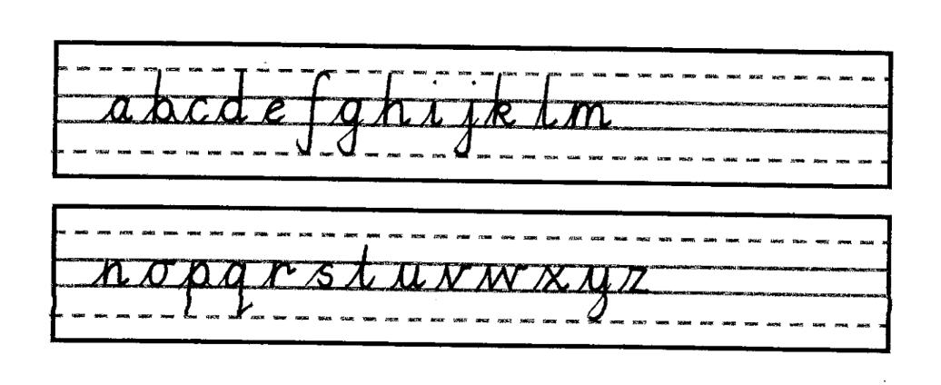

EYFS and Year 1 will follow the Little Wandle formation and EYFS follow the Little Wandle handwriting scheme.
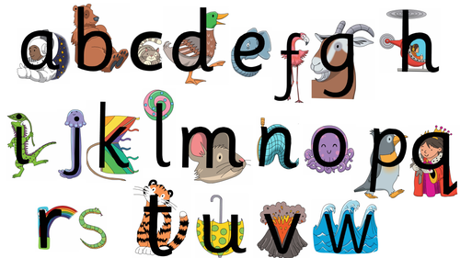

Capital Letters Y2+

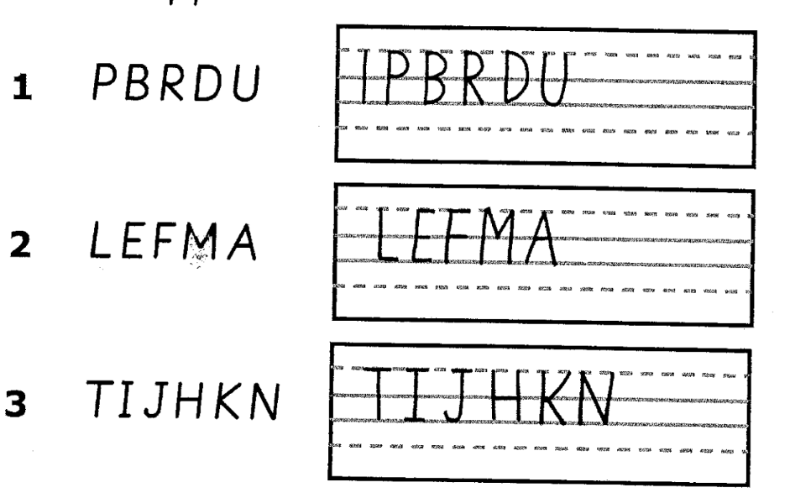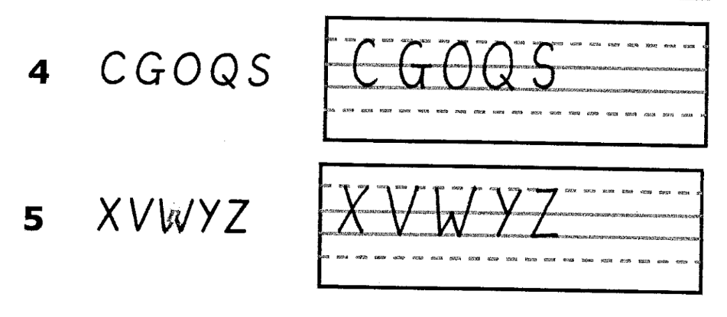

Statutory expectations in the Foundation Stage

ELG: Fine Motor Skills
Children at the expected level of development will:
- Hold a pencil effectively in preparation for fluent writing – using the tripod grip in almost all cases.

ELG: Writing
Children at the expected level of development will:
- Write recognisable letters, most of which are correctly formed;
- Write simple phrases and sentences that can be read by others.

Development Matters

Physical Development

Birth to 3
Develop manipulation and control.
Explore different materials and tools.

3-4
Use large-muscle movements to wave flags and streamers, paint and make marks.
Use one-handed tools and equipment, for example, making snips in paper with scissors.
Use a comfortable grip with good control when holding pens and pencils.
Show a preference for a dominant hand.

Reception
Develop their small motor skills so that they can use a range of tools competently, safely and confidently. Suggested tools: pencils for drawing and writing, paintbrushes, scissors, knives, forks and spoons.

Use their core muscle strength to achieve a good posture when sitting at a table or sitting on the floor.

Develop the foundations of a handwriting style which is fast, accurate and efficient.

National Curriculum

YEAR 1 EXPECTATIONS

STATUTORY REQUIREMENT
Pupils should be taught to:
- sit correctly at a table, holding a pencil comfortably and correctly (also EYFS expectation)
- begin to form lower-case letters in the correct direction, starting and finishing in the right place (also EYFS expectation)
- form capital letters
- form digits 0-9
- understand which letters belong to which handwriting ‘families’ (i.e. letters that are formed in similar ways) and to practise these.

NON STATUTORY
Handwriting requires frequent and discrete, direct teaching. Pupils should be able to form letters correctly and confidently. The size of the writing implement (pencil, pen) should not be too large for a young pupil’s hand. Whatever is being used should allow the pupil to hold it easily and correctly so that bad habits are avoided. It is our expectation that handwriting is taught daily in Year 1.
Left-handed pupils should receive specific teaching to meet their needs.

YEAR 2 EXPECTATIONS

STATUTORY REQUIREMENTS
Pupils should be taught to:
- form lower-case letters of the correct size relative to one another
- start using some of the diagonal and horizontal strokes needed to join letters and understand which letters, when adjacent to one another, are best left unjoined
- write capital letters and digits of the correct size, orientation and relationship to one another and to lower case letters
- use spacing between words that reflects the size of the letters.

NON STATUTORY (BUT EXPECTED AT OUR SCHOOL)

Pupils should revise and practise correct letter formation daily. They should be taught to write with a joined style as soon as they can form letters securely with the correct orientation.

YEARS 3 & 4 EXPECTATIONS

STATUTORY REQUIREMENTS
Pupils should be taught to:
- use the diagonal and horizontal strokes that are needed to join letters and understand which letters, when adjacent to one another, are best left unjoined
- increase the legibility, consistency and quality of their handwriting [for example, by ensuring that the down strokes of letters are parallel and equidistant; that lines of writing are spaced sufficiently so that the ascenders and descenders of letters do not touch].

NON STATUTORY (BUT EXPECTED AT OUR SCHOOL)
Pupils should be using joined handwriting throughout their independent writing. Handwriting should continue to be taught, with the aim of increasing the fluency with which pupils are able to write down what they want to say. This, in turn, will support their composition and spelling.

YEARS 5 & 6 EXPECTATIONS

STATUTORY REQUIREMENTS
Pupils should be taught to:
write legibly, fluently and with increasing speed by:
- choosing which shape of a letter to use when given choices and deciding whether or not to join specific letters
- choosing the writing implement that is best suited for a task.

NON STATUTORY (BUT EXPECTED AT OUR SCHOOL)
Pupils should continue to practise handwriting and be encouraged to increase the speed of it, so that problems with forming letters do not get in the way of their writing down what they want to say. They should be clear about what standard of handwriting is appropriate for a particular task, for example, quick notes or a final handwritten version. They should also be taught to use an unjoined style, for example, for labelling a diagram or data, writing an email address, or for algebra and capital letters, for example, for filling in a form.

How we teach handwriting

OVERVIEW
We use the Martin Harvey scheme to structure our teaching of handwriting from Year 2 through to Year 6. Our focus is initially on legibility and presentation, ensuring that the child feels comfortable when handwriting so that fluency is achieved. At all ages/stages we make sure that children are given the opportunity to exercise the necessary muscles in order to be able to write comfortably. Once children have a legible, joined style of handwriting we assume that they will try a pen of their choice from a given selection. We do not expect all children to write in pen; however, we do expect that they will be able to select the most appropriate writing implement for the task. (See attached guidance on furniture and tools)

When teaching handwriting we use ‘self-instructional training’ to support children to become autonomous. The steps that should be followed are:

- Warm up is modelled and then followed by child
- Adult models task whilst talking aloud, for example “to form a c I am going to start at one o’clock, curve round in this direction – to the left, and end here”
- Child performs task while adult provides instructions out loud, for example “put your pencil at one o’clock, now curve round to the left and stop”
- Child performs task and assesses with partner or self

The Martin Harvey method emphasises the importance of establishing good working habits in order to consistently achieve high quality handwriting and excellent presentation of work in every class. We aim to have these habits in place across every class in the school, during every lesson across the curriculum.

These include:
Two hands on the paper - Children are encouraged to use two hands when writing: One hand to hold the paper or exercise book and one hand to write with.
Correct posture - Good posture and correct seating position are vital components of developing good handwriting.
There are four ways in which we ensure the correct seating position:
1. Six feet on the floor - The child's two feet and the four feet of the chair. Children are discouraged from kneeling on a chair or to sit cross-legged on the chair. The chair's feet stay on floor so that children do no rock forward or forward on the chair.
2. BBC - Children should be expected to sit at tables in the BBC position (Bottom Back in Chair), this means that children do not sit with their chairs sticking out, making the classroom half its real size, with bottoms on the front edge of the chair. They pull the chair towards the table, so bottoms are at the back of the chair.
3. TNT (Tummy Near Table) - Children are expected to sit with their tummy near the table, but not squashed up to the table. This prevents sitting with the chair a long way from the table so that the children needs to slouch forward to do their word.
4. Paper Position - When writing, the paper or exercise book should be placed in an upright position. A slight angle is acceptable; however, this should not be more that 45 degrees.

These phrases are displayed in every classroom.

EYFS
From entry to the EYFS we teach:
- good gross and fine motor control
- a recognition of pattern
- a language to talk about the shapes and movements that will lead into the main handwriting movements which create the three basic letter shapes (c,l,m )

The first stage of handwriting teaching involves gross motor skill development activities, which are closely linked to whole-body movements. Children are shown how to make large movements in the air with their arms, hands and shoulders, e.g., with ribbons fixed to the ends of sticks.

Emerging letter shapes are developed in a number of ways, for example:

- Sky writing with both hands
- Making patterns on each other’s backs
- Making letter shapes in a damp sand tray

Children in this stage are provided with a variety of surfaces to make marks on, including different types of paper and card, whiteboards, chalkboards, interactive white boards, ‘magic boards’ etc. and they are given the opportunity to use a wide range of mark making tools, including pencils of varying thicknesses and colours, markers, chalk, wax crayons, pastels, paint, charcoal etc.

They have experience of a wide range of activities to develop hand and finger strength which leads on to developing a good pencil grip. When children are ready, they pick up the writing implement themselves and decide which hand they prefer, although hand dominance is often evident before this stage. They are taught to hold the pencil between the thumb and forefinger with the pencil resting on the third finger. The thumb and forefinger should also be able to move slightly so that very fine movements required for writing are possible.

Pencil grips and triangular pencils are used to encourage a good grip and children are monitored so that they do not hold the pencil too tightly which produces tension in the arm and shoulder. We also show those struggling the pom pom in the little finger trick. Children who are left-handed are encouraged to tilt their work clockwise so that they can more easily see what they have written.

Children are provided with a designated ‘writing area’ to give status to their early independent writing and develop a positive attitude to the act of writing and left-right orientation is encouraged, however mark making will be encouraged in all areas of the provision including outside.

By the end of the foundation stage, children are able to sit correctly at a table, holding a pencil comfortably and correctly and begin to form lower-case letters in the correct direction, starting and finishing in the right place. In the spring term children are taught handwriting formally at a table.

KEY STAGE 1

Children are taught handwriting skills in discrete handwriting group sessions for 10 minutes at least three times a week (as this is a motor skill ‘little and often’ works best). In the autumn term it is expected to be taught daily.

During handwriting sessions, children are taught all of the basic letter shapes, according to the Martin Harvey scheme. They follow the Little Wandle letter formation.

There is an expectation that:
- this handwriting style will be applied to all writing that the children do

KEY STAGE 2

Throughout key stage 2 handwriting skills are revised and practised in discrete handwriting lessons for 10 minutes at least 3 times a week.

There is an emphasis on applying handwriting skills to all written work. They work at a personal pace, revisiting and refining skills.

High standards of presentation are valued in each year group in order to encourage children to take pride in their work.

By the end of KS2 children should be able to write at speed when necessary and should be able to adapt their handwriting according to the task.

Inclusion
We endeavour to identify children with difficulties relating to handwriting swiftly – if we are unsure, we seek professional advice. We observe young (or new) children carefully in order to identify any issues early on.

Children identified as having a specific learning difficulty relating to handwriting have an individual based plan written in consultation with the SEND coordinator and special provisions are made to cater for their specific needs.

Children who are left handed are taught to slant their book or paper so that their writing can be read more easily. They are discouraged from holding a pen or pencil too close to the point as this can interrupt their line of vision and they are supported to choose a writing implement that is not going to smudge as they write. Additionally, a left handed child should be positioned to the left of a right handed child to enable both to write comfortably without bumping into each other.

Embracing Technology
We appreciate that in the future our children will need to be hybrid writers and should therefore be able to use a variety of communication modes and be capable of selecting which one is the most suitable to the task. Handwriting will be one mode in a toolbox of options. For all children, the facility to write using a keyboard is an important life skill. For some children, the use of a keyboard for all or most writing tasks can give the kind of automaticity they struggle with when trying to write by hand. Those relying on keyboarding will need to learn touch typing.This will be assessed on a case by case basis in discussion with the class teacher and SENCo.

How we assess handwriting
Observing children as they handwrite is the primary way that we assess handwriting. Feedback is live and verbal during handwriting lessons. In the first instance we are looking for correct letter formation (both lower case and capital letters) by observing how the letters are formed.

When we are confident that the children are forming their letters correctly, we assess whether the children’s handwriting is:

Legible – EYFS/KS1/KS2
•Presentable - EYFS/KS1/KS2
•Fluent – KS1/KS2
•Flexible – KS2
•Fast – KS2

We use our assessments for the following purposes:
- To identify next steps of learning (this is our priority)
- To ascertain whether pupils are working at age-related standards for handwriting (as set out in the EYFS Framework and National Curriculum)
- To provide evidence for end of Key Stage assessments

In addition, we use the National Curriculum end of Key Stage assessment criteria for handwriting.

Appendix
Taken from Little Wandle.
